Infrastructure Funding Statement 2019/2020

INTRODUCTION

Local Planning Authorities are now required to produce an infrastructure funding statement on an annual basis as a result of government guidance. This is Lancaster City Council’s first infrastructure report and will be updated on an annual basis. This report provides a summary of the Section 106 Planning Obligations, also known as Developer Contributions, that the Council has secured, received and spent from planning permissions for off-site and on-site infrastructure in 2019/2020.

In summary, the report provides:

- An overview of Section 106 Planning Obligations secured in 2019/2020;
- Financial contributions and provisions received under a Section 106 Planning Obligation received by the Council in the 2019/2020 monitoring period;
- Financial contributions that have been spent in 2019/2020; and
- Financial contributions that have been received under a Section 106 Planning Obligation prior to 2019/2020 but are currently unspent.

The information included in the report will be updated annually and published on the Council’s website meaning the information will be readily available to members of the public and other interested parties. This report will present the most up to date information on the amount of Section 106 Planning Obligations received by the Council from new developments, and on where these monies have been spent. If you have any other queries about Section 106 Planning Obligations you can email S106@lancaster.gov.uk

SECTION 106 OBLIGATIONS

Under section 106 (s106) of the Town and Country Planning Act 1990 a Local Planning Authority (LPA) can seek obligations from the developer, also referred to as ‘Developer Contributions’ or ‘Planning Obligations’ or ‘Section 106/S106 obligations’. Section 106 Planning Obligations are legal obligations entered into to mitigate the impacts of a development proposal. Councils should consider whether otherwise unacceptable development could be made acceptable through the use of conditions or Section 106 Planning Obligations. Section 106 Planning Obligations should only be used where it is not possible to address unacceptable impacts through a planning condition, and they must meet the following tests:

- necessary to make the development acceptable in planning terms;
- directly related to the development; and
- fairly and reasonably related in scale and kind to the development.

They are used to individually or collectively fund infrastructure that is required to support the development.

For example, new residential developments place additional pressure on existing social, physical and economic infrastructure in the surrounding area. Developer contributions aim to balance this extra pressure with improvements to the surrounding area to ensure that a development makes a positive contribution to the local area (for example, contributions towards education, providing areas of open space or highway improvements).

The obligations may be provided directly by the developers. For example, the developer may build a certain number of affordable homes on-site. Alternatively, contributions can be met in the form of financial payments to the Council to provide off-site infrastructure works or contributions towards providing affordable housing elsewhere in the District.

The Council cannot ask for contributions via section 106 planning obligations in certain circumstances:
“Planning obligations for affordable housing should only be sought for residential developments that are major developments…For residential development, major development is defined in the National Planning Policy Framework as development where 10 or more homes will be provided, or the site has an area of 0.5 hectares or more. For non-residential development it means additional floorspace of 1,000 square metres or more, or a site of 1 hectare or more. Planning obligations should not be sought from any development consisting only of the construction of a residential annex or extension to an existing home.”

Planning Practice Guidance 2019 Paragraph 023 ‘Planning Obligations’ https://www.gov.uk/guidance/planning-obligations

S106 OBLIGATIONS THAT HAVE BEEN SECURED IN 2019/2020
Between 1 April 2019 to 31 March 2020 there were 7 planning permissions issued that had a S106 agreement with developer obligations attached to the consent. These are:
Planning Application Ref | Development Address | Proposal | Obligations
17/00345/FUL | Royal Lancaster Infirmary  Ashton Road Lancaster  Lancashire | Erection of 6 storey staff car park on the site of the existing staff car park (west of main hospital complex) and the regrading, resurfacing and new layout of entrance/exit routes to the existing visitors car park (east of main hospital complex) and erection of a single storey day nursery (D1) | - Funding of one bus for the Park and Ride  - £75,000 contribution to Lancashire County Council towards pedestrian/cycle improvements to the Pointer Roundabout  - £6,000 contribution to Lancashire County Council for travel plan support  - £10,000 contribution for the bus stop and safety improvements at the Park and Ride site  - £10,000 contribution to Lancashire County Council for the review and implementation of residential parking schemes close to the hospital site
17/01502/FUL | Heaton Hall Morecambe Road  Lancaster  Lancashire | Change of use and conversion of the tavern into five dwellinghouses (C3) including the demolition of the existing conservatory and associated motel building and the erection of nine dwellinghouses (C3) with associated landscaping and vehicular parking | - Affordable Housing Contribution £18,831  - Provision, management and maintenance of open space (including landscaping, play equipment and general open space), non-adopted highways and non-adopted surface water arrangements
18/00335/FUL | Land North East Of St John’s Church  Chapel Lane  Galgate  Lancashire | Erection of 32 dwellings (C3) with associated access and landscaping | - Public open space provision on the development and management  - Occupancy restrictions to the dwellings
18/00365/OUT | Land to the east of Scotland Road  Carnforth  Lancashire | Outline application for residential development comprising 213 dwellings (Use Class C3) with associated vehicular and cycle/pedestrian access to Scotland Road and cycle/ pedestrian access to Carnforth Brow/Netherbeck, public open space, creation of wetlands area, construction of attenuation basins, erection of sub-station, installation of a pumping station and associated earth works and land regrading and landscaping | - Affordable Housing Provision – to be determined at the Reserved Matters Application  - Education contribution- to be determined at the Reserved Matters Application  - Provision of a Wetland Conservation Area  - Provision, management and maintenance of open space lane and public open space  - Highways Contribution for £7,500 to be paid to Lancashire County Council
18/01603/FUL | Warton Grange Farm Farleton Close  Warton  Carnforth  Lancashire | Erection of 4 dwellings with associated access and landscaping | - Application links with application reference 15/00847/OUT  - Affordable Housing Provision of 3 units as set out in the original S106 agreement under reference 15/00847/OUT  - Education Contribution as set out in the original S106  agreement under reference 15/00847/OUT
18/00002/FUL | Land at Mill Lane  Low Mill  Mill Lane  Caton  Lancashire | Erection of 9 dwellinghouses with associated access, engineering works to provide sustainable drainage pond, construction of internal roads and footways and the provision of a package treatment plant | - Provision of 2 Affordable Housing Units  - Provision of a footpath on the development site and connect the footpath to the existing cycle route  - Provision, management and maintenance of open space land
19/01336/VLA | Land opposite 26 to 38 Lancaster Road  Overton  Lancashire | Variation of legal agreement attached to planning permission 16/01136/FUL to amend the affordable housing provisions | - This is a variation to the original S106 agreement for application 16/01136/FUL which amends the affordable housing provision from 12 affordable units to an increased amount of 32 affordable units.

The above agreements can be viewed at http://www.lancaster.gov.uk/planning/view-applications-and-decisions
AFFORDABLE HOUSING PROVISION 2019/2020
25 affordable housing units were completed on developments in the Lancaster District and transferred to a registered provider in 2019/2020. These provisions were secured through previous S106 agreements:
Planning Application Ref. | Development Address | No. of Affordable Units Provided
14/00768/OUT | S J Bargh Ltd  H  ornby Road  Caton  Lancaster | 9 (5 shared ownership and 4 affordable rent)
16/01487/VLA | Land east of railway line  St Michaels Lane  Bolton Le Sands  Lancashire | 4 (4 shared ownership)
14/00270/OUT | Land off Sycamore Road  Brookhouse  Lancaster | 4 (4 shared ownership)
15/00720/REM | Land Opposite Greendale Drive  Mill Lane  Warton  Lancashire | 8 (4 shared ownership and 4 affordable rent)

AFFORDABLE HOUSING CONTRIBUTIONS 2019/2020
No affordable housing contributions were received in 2019/2020. This is due to the council successfully securing provision of on-site affordable housing in lieu of a contribution.
To date, the total of unspent affordable housing contributions stands at £559,000.
On 14 July 2020 Cabinet approved £375,000 of the above funds to be awarded to Lune Valley Community Housing Trust to bring forward a new scheme of affordable housing in Halton. It is anticipated the sum of £375,000 will be spent in 2020/2021 towards this project. This will leave a balance of £184,000 which will be used for future affordable housing projects in the District. Please note that the affordable housing contribution amount is not defined to a specific timescale.

OTHER FINANCIAL CONTRIBUTIONS RECEIVED IN 2019/2020
The table below outlines financial contributions received under a Section 106 Planning Obligation in 2019/2020
Planning Application Ref | Development Address | Contribution Amount | Contribution Purpose
14/00633/VCN | Land at Lawsons Bridge  Scotforth Road  Lancaster  Lancashire | £65,000  Contribution has been allocated but currently unspent | This contribution was secured to enable the council to create a pedestrian/cycleway on a designated area near the site. The council’s engineers are in the early stages of getting the project underway. It is anticipated that the contribution will be spent in 2021/2022.
17/00165/OUT | Land between Low Road and Forge Lane  Halton  Lancashire | £16,000  Contribution has been allocated but currently unspent | This contribution is for pitch improvements on the playing field next to The Centre in Halton. Halton-with-Aughton Parish Council and Lancaster City Council are currently in talks about the necessary works to improve the playing pitch. It is anticipated that the contribution will be spent in the financial year 2021/2022.

CONTRIBUTIONS SPENT IN 2019/2020

Below is a table that sets out S106 contributions that have been received in previous financial years and spent in year 2019/2020.

Planning Application Ref | Development Address | Contribution Amount | Contribution Purpose | Spending details
12/00834/OUT | Laund Fields  Stoney Gate  Galgate  Lancaster  Lancashire | £21,250 | Public Open Space contribution towards maintenance, upgrade and improvement of the existing play area on Beech Avenue, Galgate. | Contribution spent on ‘Wicksteed’ play equipment at the play area on Beech Avenue, Galgate.
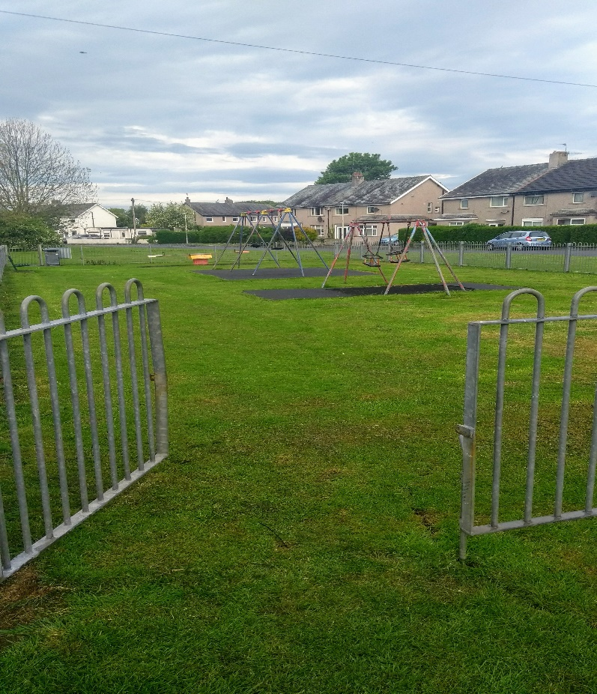
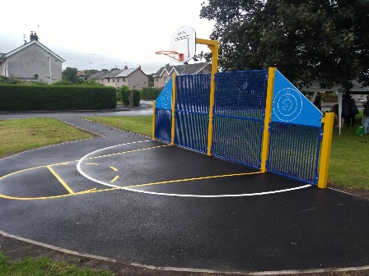
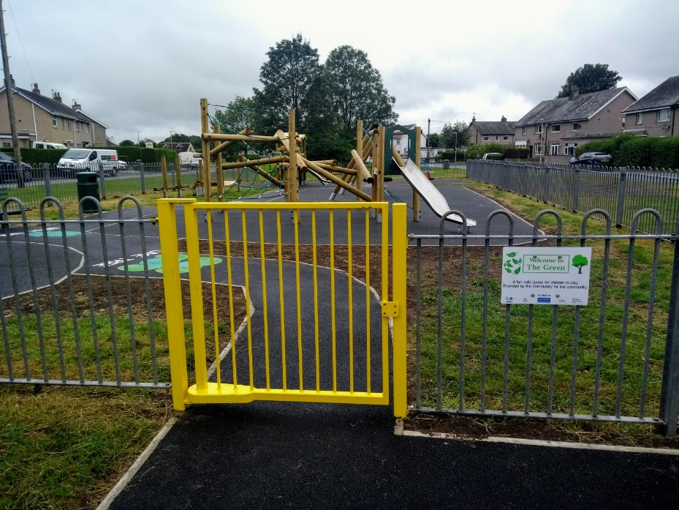
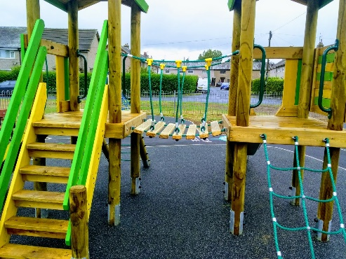
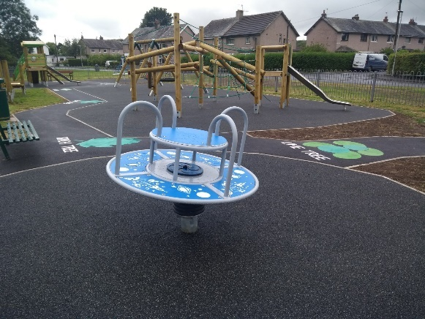
Below are images of the play park at Beech Avenue, the central image is before the works were carried out and images left and right are after. As well as the S106 contribution, the park also received funding from The Lottery, Lancashire Environmental Fund and Council Housing.
CONTRIBUTIONS RECEIVED PRIOR TO 2019/2020

Local Planning Authorities now need to report on unspent contributions received in previous years. The table below shows all unspent contributions secured prior to 2019/2020 and states whether the contribution has been allocated and remains unspent, or has not yet been allocated.

Planning Application Ref. | Development Address | Contribution Amount | Contribution Purpose | Contribution Position | Payback date
14/00129/FUL | Nightingale Hall Farm, Quernmore Road, Lancaster, Lancashire | £70,000 | Contribution for a creation of a cyclepath from Derwent Road to the City Centre | Allocated but unspent | 31 July 2020
99/00087/FUL | 10-12 Market Street, 33-39 Church Street, Lancaster & Mitre House Car Park | £10372.85 remaining | Contribution is to be used for a grant fund for historic homes in Lancaster City Centre | Allocated but unspent | No payback
09/01204/FUL | Land at Lansil Industrial Estate, Lansil Way, Lancaster | £25,000 | Contribution to County Council towards Real Time Bus Information | Project could not be brought forward, due to be reimbursed | No payback, due to be reimbursed
10/00157/FUL | Galgate Ex Service and Working Mens Club, Chapel Street, Galgate, Lancaster | £2,000 | Contribution to County Council for the implementation of 20mph zone on Chapel Street, Galgate | Allocated but unspent, due to be reimbursed | 27/08/2015
13/00122/VCN | Lancaster Moor Hospital, Quernmore Road, Lancaster, Lancashire | £217 remains from original £131,783 contribution | Contribution to County Council for a cycleway along Quernmore Road | Allocated but £217 remains unspent, due to be reimbursed | 14/02/2018
14/00587/VCN | Luneside West Development Site, Thetis Road, Lune Business Park, Lancaster, Lancashire | £3,500 remains from £5,500 contribution | Contribution towards footpath link | Project could not be implemented. £3,500 to be reimbursed | 09/10/2019
14/00587/VCN | Luneside West Development Site, Thetis Road, Lune Business Park, Lancaster, Lancashire | £3,500 remains from £5,700 contribution | Contribution towards footpath link | Project could not be implemented. £3,500 to be reimbursed | 09/10/2019
15/00813/FUL | Land adjacent Campbell Drive, Lancaster | £72,008.50 | Contribution towards pitch improvements at Far Moor playing fields, Lancaster | Allocated but unspent | 09/06/2022
16/00255/VCN | Land north of 1 to 23 Stoney Lane, Galgate, Lancashire | £216,533 | Education Contribution for 18 school places at St John The Evangelist Church of England Primary School in Galgate | Allocated but unspent | No payback date
15/01278/FUL | Land at Coastal Road, Bolton Le Sands, Lancashire | £9,276 remains from £24,196 Open Space Contribution | Open Space Contribution to be spent on City Council parks | Allocated but unspent | 12/09/2022
14/00129/FUL | Nightingale Hall Farm, Quernmore Road, Lancaster, Lancashire | £71,283 | Education Contribution | Not allocated | 25/08/2022
14/00129/FUL | Nightingale Hall Farm, Quernmore Road, Lancaster, Lancashire | £4,400.74 | Indexation payment in respect of Education Contribution for £71,283 | Not allocated | 19/03/2023

FUTURE S106 CONTRIBUTIONS

In 2020/2021 the following contributions are expected to be received by the council:

Planning Application Ref. | Development address | Contribution Amount | Contribution Purpose
13/01274/FUL | 47-51 North Road  Lancaster  Lancashire | £17,000 | Highways contribution towards the provision of a Toucan Crossing in a specified area.
17/00165/OUT | Land between Low Road and Forge Lane  Halton  Lancashire | £149,281.75 | Education contribution (part 1 of 2) for 21 primary school places within a 2 mile radius of the development site
16/01081/VCN | Agricultural building adjacent to disused railway  Station Road  Hornby  Lancashire | £26,000 | Affordable housing contribution
16/00574/FUL | Luneside East  St Georges Quay  Lancaster  Lancashire | £19,000 | Contribution towards the provision of a footpath in a specified area

MONITORING FEES 2019/2020

Local Planning Authorities must report on monies received under planning obligations that are spent in respect of monitoring in relation to the delivery of planning obligations. Lancaster City Council currently does not receive monitoring fees by means of a S106 agreement or other method.

