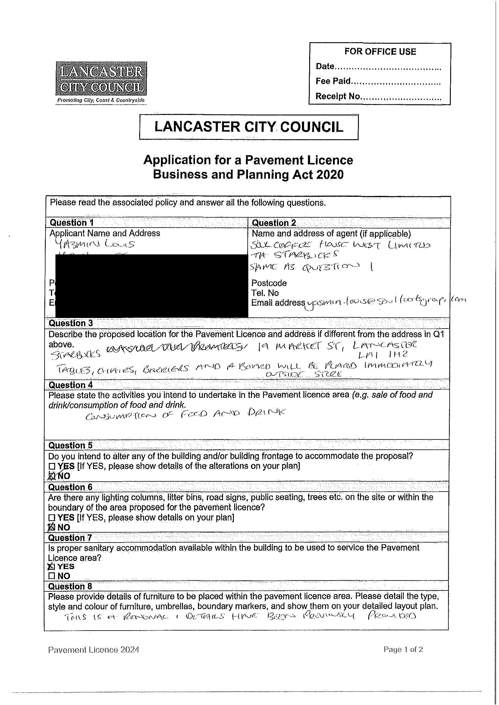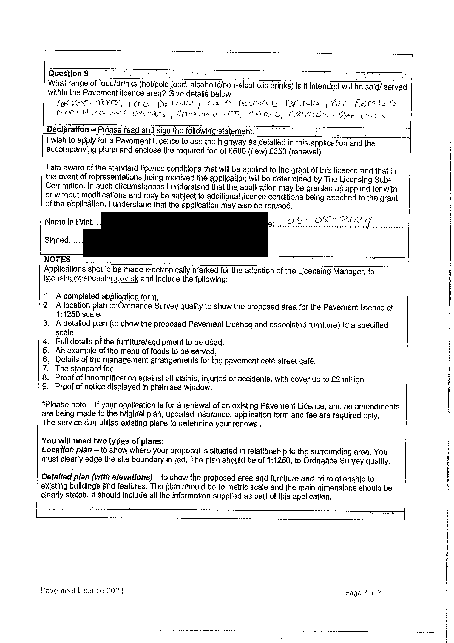

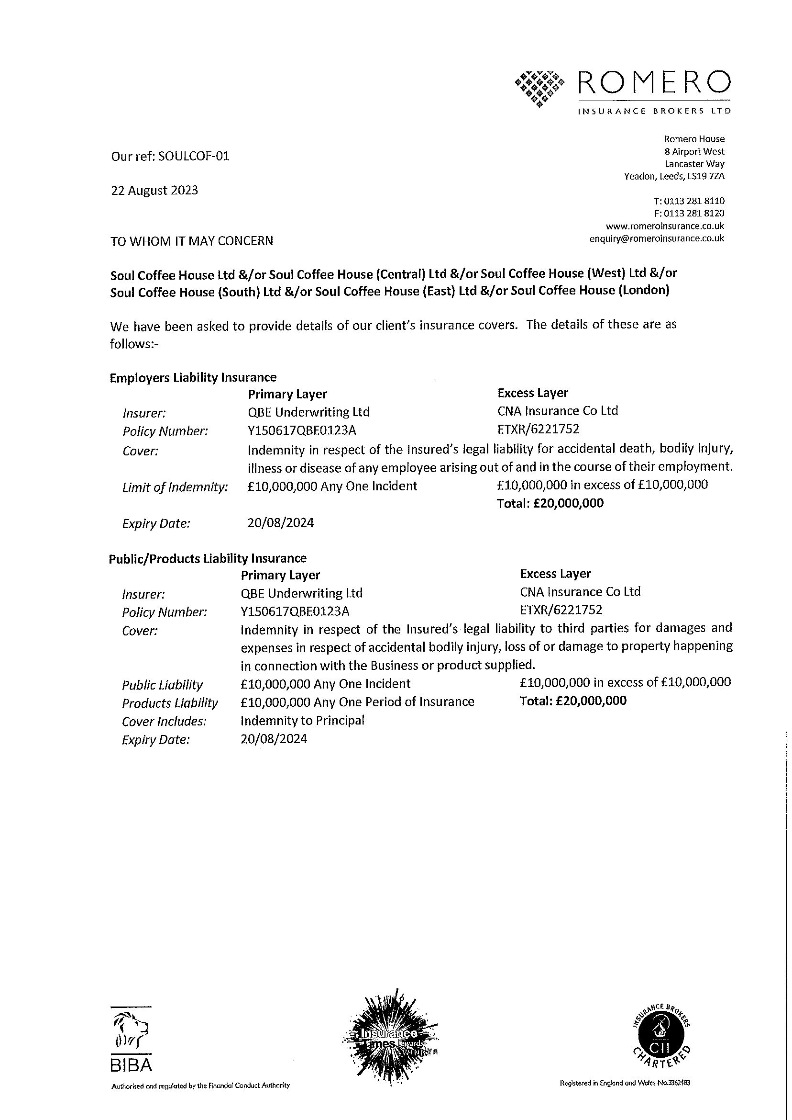

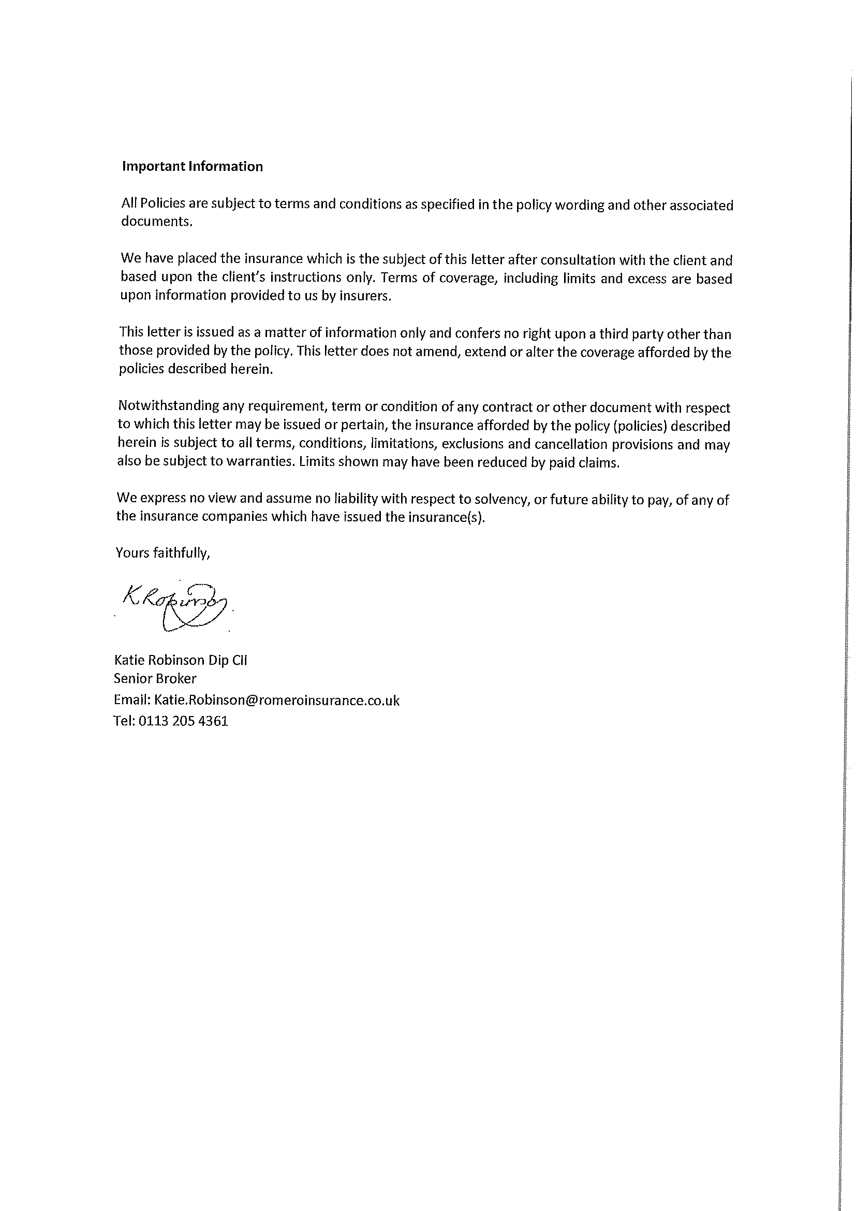

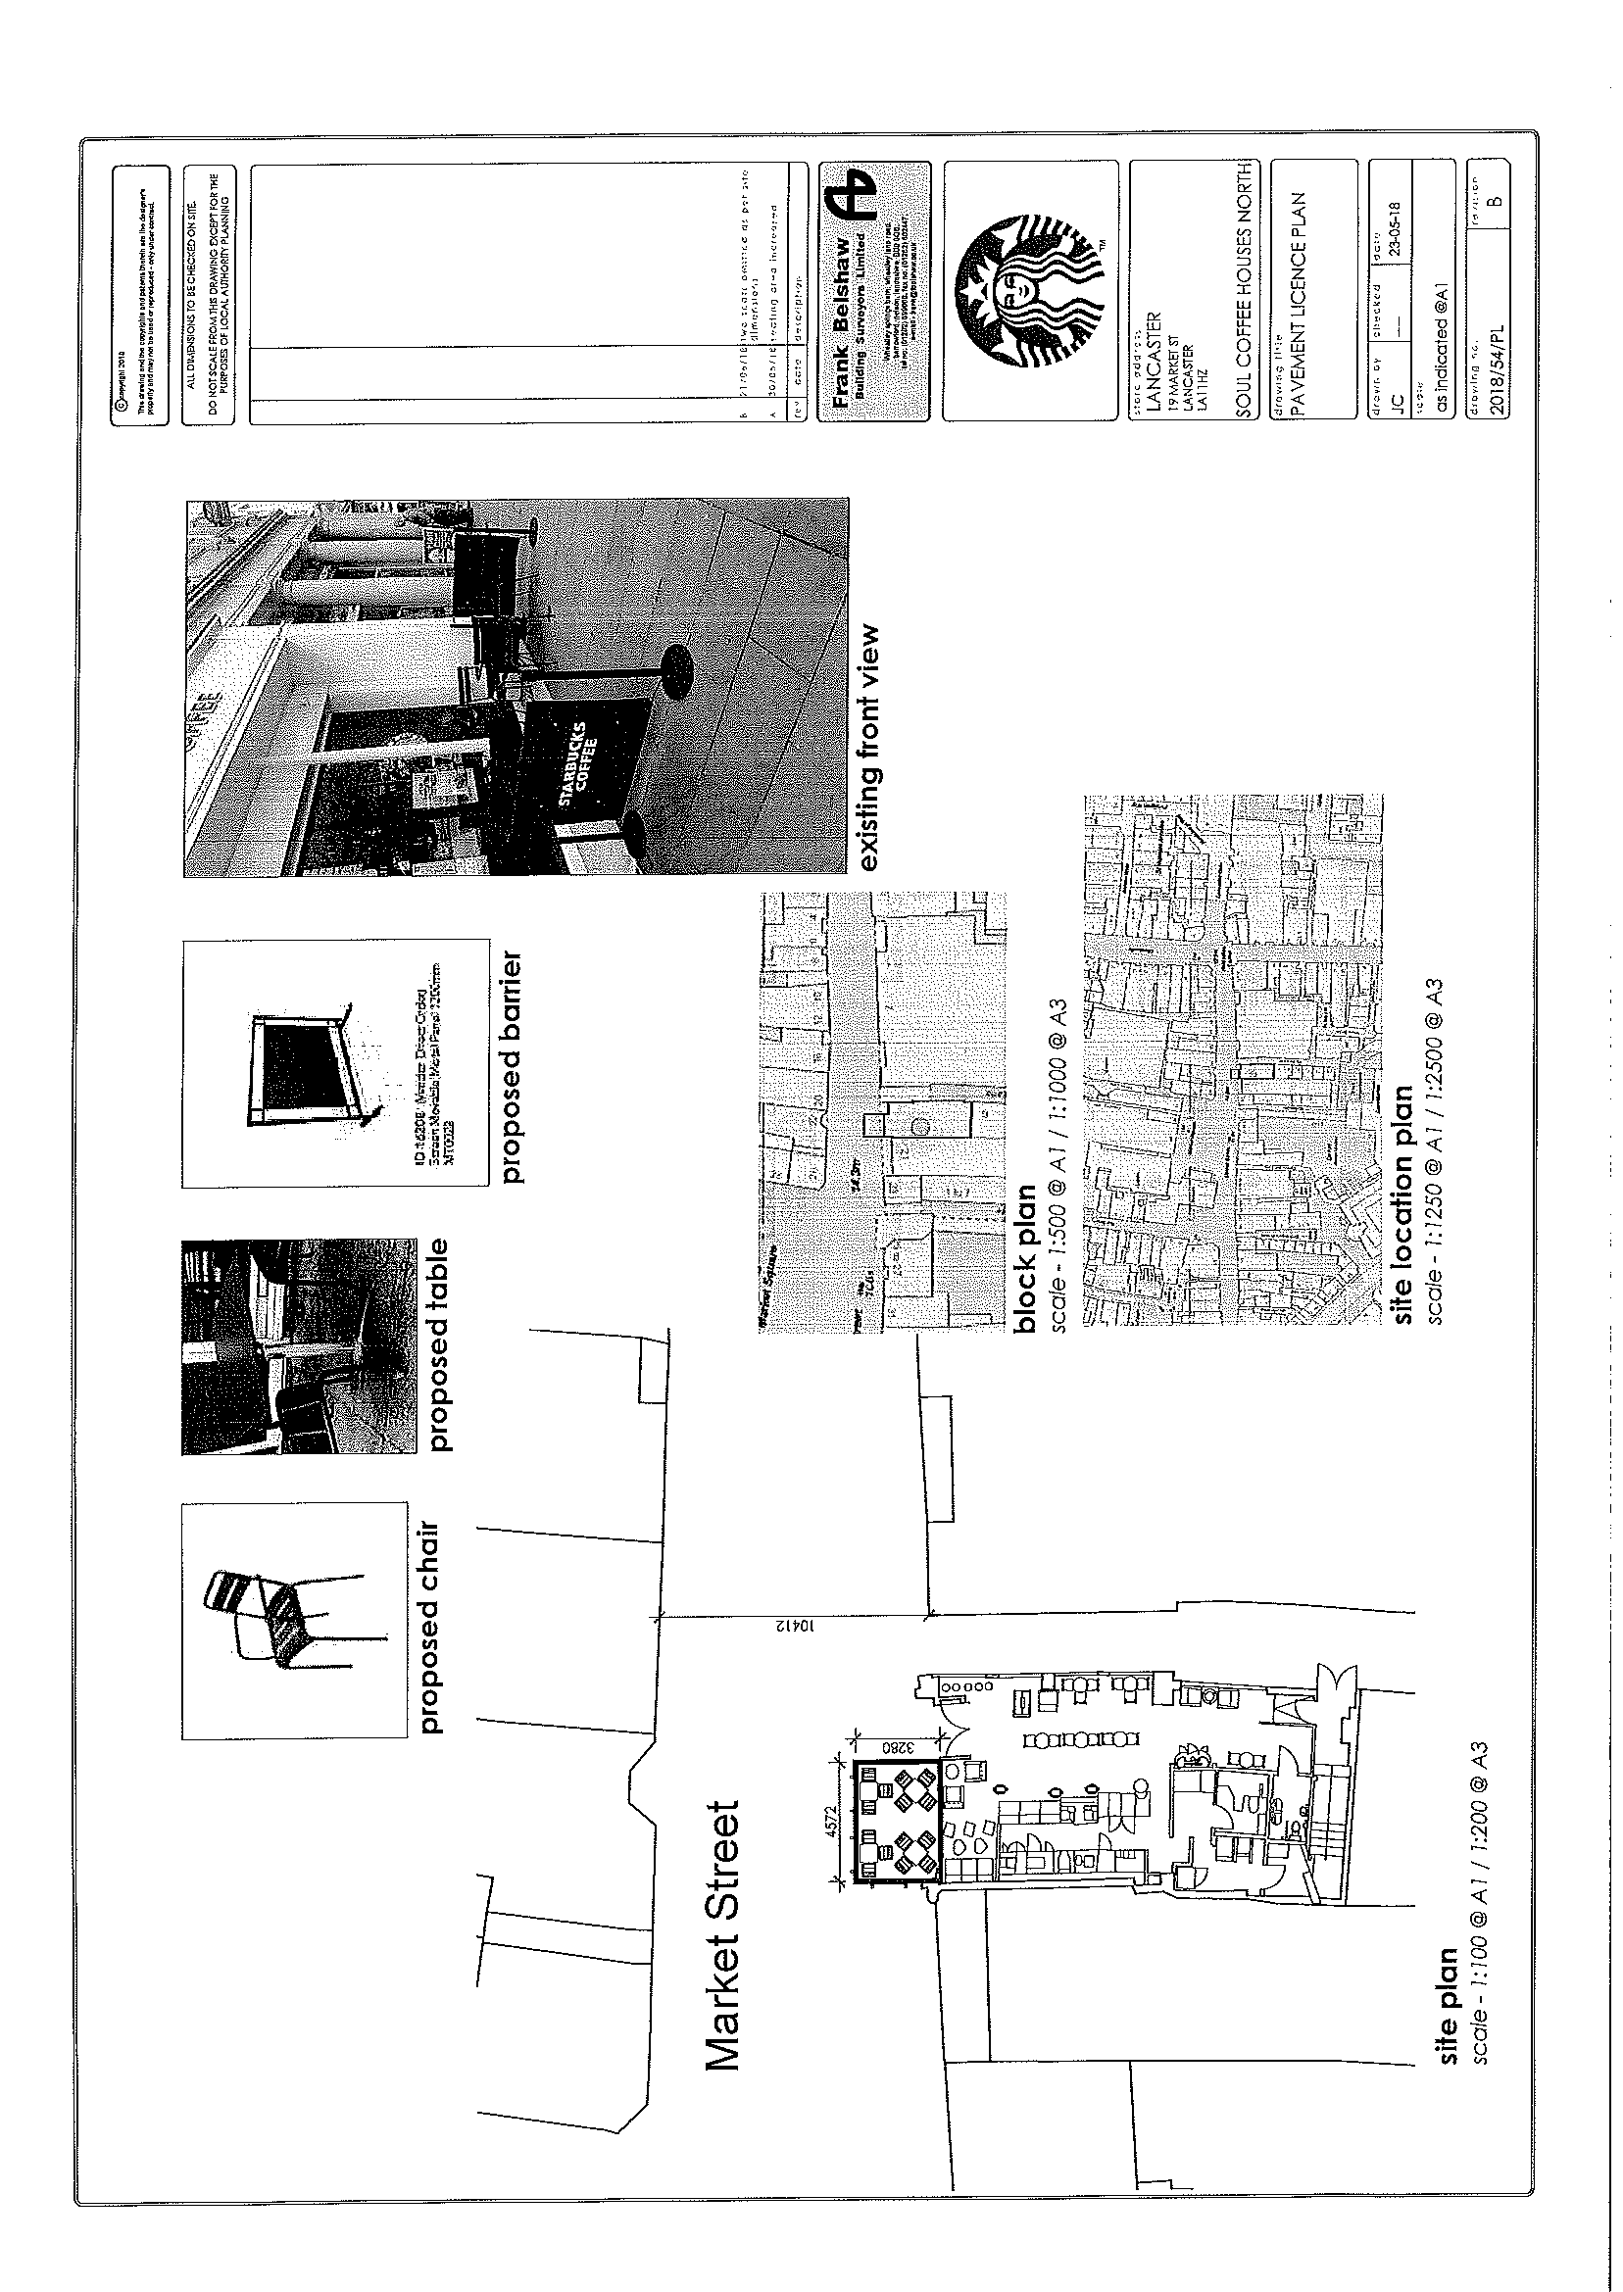



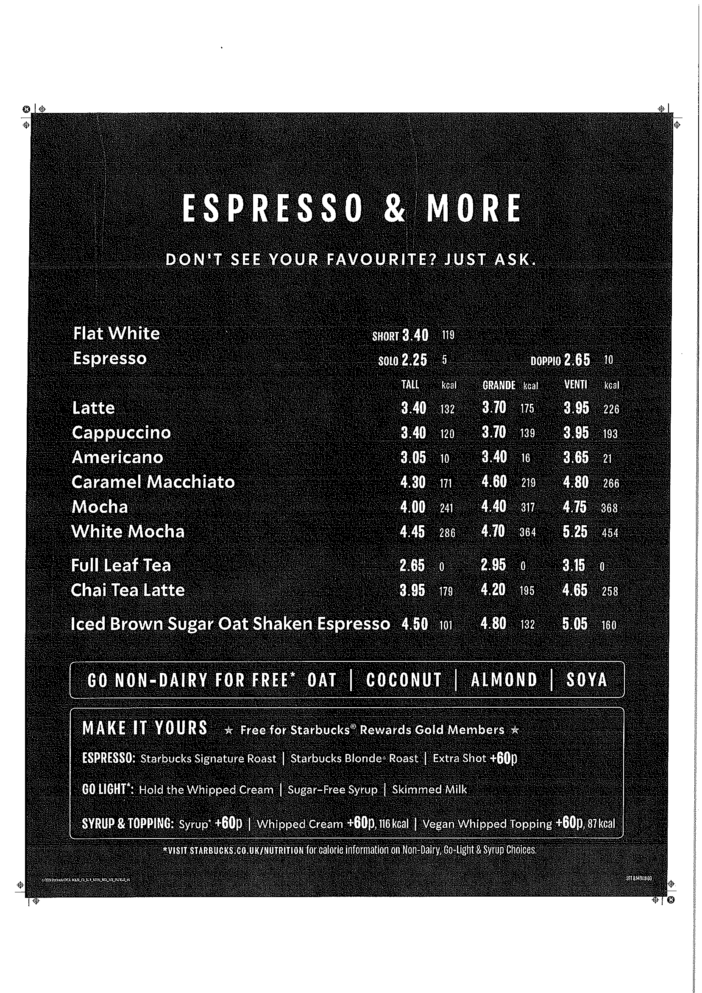

Starbucks

19 market street

Lancaster

La1 1HZ

Management plan regarding outside seating area:

Bussing routines carried out every 20 minutes or as frequent as needed for level of business.

Red fire proof ash tray bin for emptying ashtrays after customer usage.

Sweep and mop outside seating area before and after placing furniture outside.

Regular deep cleaning with deck scrub brushes twice a week to clean hard to mop areas.

Regular sweeping of floor outside around fallen debris from food and paper serve ware.

The only ceramic items to be outside for customers are cups and plates.

Furniture to only be placed in correct designated area laid out in floor plan, and only to be placed after 9am in a morning, and to be brought inside no later than 7pm due to a store closure of 6.30pm.

Regards,

Rebecca Birkby.

Store Manager.



