

**C**

Lancaster City Council

**Promenade Permits**

# APPLICATION PACK (C)

Mooring Registration - **Promenade Access** (includes commercial fishermen)

**PACK INCLUDES:**

## How to apply for your permit

## Code of Conduct

## Application Form

## Mooring Location Maps

## Data Protection Notes

**Please return the Application Form, along with your location maps ONLY.**

**All other information is for your own records.**



Any queries in regard to this application pack should be emailed to:

**customerservices@lancaster.gov.uk**

**How to apply for your permit**

**When accessing Morecambe’s waterfront for a specific reason (i.e. launching**

**a fishing vessel) a permit is required. This is obtainable from Lancaster City**

**Council. You can apply for a permit in the following way:**



**BY POST**

Please return applications with the required documentation to:

**Promenade Permits, Town Hall, Marine Road East, Morecambe, LA4 5AF.**

http://www.eoa.co.uk/userfiles/images/email-symbol.jpg

**BY EMAIL\***

You can email your completed application to: **PublicRealm@lancaster.gov.uk**

**\*Please note applications sent via email will need to contain a signature or it will not be accepted**



**IN PERSON**

Completed applications can be dropped off at:

**Morecambe Town Hall, Monday – Friday, 09:00 – 17:00**

**P**

**a**

**ge**

**1**

**Annual Charges**

**NB: Charges may change without prior notice.**

|  |  |  |
| --- | --- | --- |
| **Launching Permit** | Powered or non-powered craft | **£29.00** |
| **Disabled Angler Permit** | For use on Stone Jetty | **£29.00** |
|  | For use on Grosvenor Breakwater | **£15.00** |
| **Mooring Application** | All vessels | **NO CHARGE** |
| **Stone Jetty Commercial Access** | All commercial vessels | **NO CHARGE** |
| **Quad Bike Slipway Permit** | Commercial fishing **ONLY** | **£92.00** |
| **Quad Bike Bond** |  | **£336.00** |
| **Datatag** (one off charge) | Powered craft **ONLY** | **£75** |

 **Code of Conduct**

**P**

**a**

**ge**

**2**

**Permit holders must agree and abide by the following when accessing Morecambe Promenade and its waterfront.**

**Coastal users should:**

•Be in possession of a valid permit, obtained from Lancaster City Council, allowing access to Morecambe’s promenade to launch a vessel/craft. The permit must be displayed in the **front** windscreen of the towing vehicle.

•Have valid insurance documentation and a datatag (powered craft only) for the vessel planning to be launched. If not, access to the slipway will be refused.

•Register all **powered** craft with a datatag. In some cases, jet skis may already be registered. If this is the case, Lancaster City Council requires proof and access to the vessel identification number.

•Keep slipways clear of obstruction at all times. Please be aware that **no** parking is permitted on the foreshore.

•Indemnify Lancaster City Council, its employees and agents against any and all actions, costs, losses, damages, injury, charges, claims, expenses and damage whatsoever arising directly or indirectly from the use of the foreshore, except damage and injury arising from the negligence from the council and that of all its employees and agents.

•Observe all statutory provisions, regulations and orders as well as notices or documents received pursuant to any such requirement provision, regulation or order.

•Under no circumstances deposit litter or any other waste (including fish, shellfish or bait) on the foreshore or any adjoining land.

•Be aware that there are limited parking spaces available around the slipways, therefore, if occupied, vacant spaces elsewhere will have to be sourced.

•Be over 12 years of age to operate any **powered** vessel/craft. Be under direct supervision of an adult at all times while using any **powered** vessel/craft, if aged between the ages of 12 and 16 years. Hold a valid RYA PWC certificate of competence if riding a Jet Ski/PWC.

•Display a valid datatag licence on the vessel/craft, below the handlebars. This is required for **powered** crafts only.

•Always check weather reports, allow someone to know what time you expect to be back and check all safety equipment before leaving the waterfront.

•Only access the promenade during the hours of daylight.

•Understand that datatags have a unique vessel identification number, which is assigned to the **vessel** and not its owner. Therefore it remains with the boat. If you wish for another craft to be registered, a new datatag must be obtained.

**NB: Permits can be revoked following non-adherence to any of the above conditions.**

**There is a speed limit of 10 mph and hazard lights must be in use while in motion on the promenade.**

**In the event of an emergency, dial** 999 **and ask for the coastguard**

**Page 3**





**APPLICATION FORM C**

Mooring Access & Registration

(Including Commercial Fishermen)

**Instructions:**

**C**

To enable you to moor you vessel/craft, accessing through Carton Terrace Breakwater, you need to be in the possession of a permit. This permit enabled you to access the promenade, however to be able to moor your craft a registration form must be completed – stating the desired location of your mooring, which is included in this pack [part (d)]. The permit is obtainable from the council on completing and returning this application pack to:

Promenade Permits, Town hall, Marine Road East, Morecambe, LA4 5AF.

**NB:** Your permit will only need to be renewed if your vehicle registration details change.

**This form is split into four colour-coded sections**

General Information

Access Permit Application

Mooring Registration

Mooring Location

**a**

**b**

**Items to be attached on submitting this form:**

To enable us to process your application, it is essential we have the following items:

* **2x Passport sized photographs of applicant** (45mm-35mm)
* **All parts (a), (b), (c) & (d) completed**
* **Photograph of the vessel you plan to moor**
* **Photocopy of the vessels liability insurance** (if policy is held)

If applying for **commercial purposes**, you will need to supply this additional information:

* Certificate of British Registry (valid and up to date)
* Vessel inspection certificate
* DEFRA Vessel license
* There is **no** charge for moorings.
* The permit will only need to be renewed if your vehicle registration details change.
* For commercial purposes, we will require renewed copies of any related documentation once they expire.
* We advise that you hold a valid insurance policy for any moored vessel but it is not essential.
* When received, the permit should be displayed **clearly** in the **front** windscreen on your vehicle, when attending the permitted vessel.

**Important Notes**

**This form is split into four colour-coded sections**

**Page 4**

General Information

Access Permit Application

Mooring Registration

Mooring Location

**Please Note:**

All sections must be completed for the application to be accepted. There is **NO** charge for this application.

**d**

**c**

This form can be used to **apply** for, or **renew** your access and mooring registration permit, granting permission to enter the promenade via Carlton Terrace Breakwater or The Stone Jetty Breakwater (commercial only) and access the vessels registered mooring. The permit is strictly **non-transferrable**.

Please use **BLOCK CAPITALS** when completing this form. **DATE OF APPLICATION:**

Use **BLACK INK** only

|  |  |  |  |  |  |  |  |  |  |
| --- | --- | --- | --- | --- | --- | --- | --- | --- | --- |
| D | D |  | M | M |  | Y | Y | Y | Y |

**Please (🗸) the most appropriate:** This is a new application This is a renewal

**Part A:** General Information on moored vessels

1. **Applicant’s details**
2. Surname

(b) Forename

b) I do not own a swipe card and will need to obtain one

1. I already own a swipe card to gain access (8 digit no)

**3. Swipecard Ownership (Stone Jetty only)**

**Part B:** Access to Promenade

The following sections are to enable you to apply for access, via the Carlton Terrace Breakwater or Stone Jetty, to your vessels mooring. Without an access permit, access to the promenade will be denied.

**Page 5**

**2. Reason for Access** Recreational Commercial Fishing

1. Manufacturer (d) Model
2. Vehicle Registration Number (b) Colour
3. **Details of Towing vehicle**

(b) Colour of vessel/craft

1. Vessel name **or** Identification marks
2. **Vessel/Craft details**

(e) Postcode

(c) Email Address

(d) Postal address

(c) Phone number

**4. Declaration of Insurance(s)**

1. I hereby apply for permission to launch a vessel/craft in accordance with the attached conditions and agree to fully observe these at all time and to be fully bound thereby. I understand that I have been advised to hold insurance for my craft so that it is insured for public liability to a minimum of £2,000,000 and that I am liable for any damage or injury caused by the moored vessel. I have also read and understood the code of conduct.
2. By signing (i), you agree with the conditions regarding the launch of you vessel and are advised to hold valid insurance.
3. I hereby apply for permission to drive on the Promenade in accordance with the attached conditions and agree to fully observe these at all times and to be fully bound thereby.

My vehicle is insured for use on the Promenade as land owned by Lancaster City Council.

1. By signing (ii), you agree with the conditions regarding the towing of your vessel and certify you hold valid car insurance.

|  |  |  |  |  |  |  |  |  |  |
| --- | --- | --- | --- | --- | --- | --- | --- | --- | --- |
| D | D |  | M | M |  | Y | Y | Y | Y |

(c) Signed (d) Date

(e) Print name

**Page 6**

Yes, I own a dingy/side float/punt in addition to my vessel/craft, which I have already listed.

No, I only have ownership of my vessel/craft, which I have listed.

If **yes**, please answer the following:

(b) Any identification marks

(c) Colour

1. In addition to the vessel/craft listed in the general information of this form, do you own a dingy/side float or punt?

Please tick most appropriate (🗸)

1. **Other purposes**

**Part C:** Mooring Registration

The following sections are to enable you to apply for a mooring location, entitling you to moor your craft in the desired area. Without parts A & B completed, this application will be denied.

* Vehicles will only be permitted to enter the promenade when attending the mooring.
* There is a speed limit of 10mph and hazard lights must be in use while in motion on the promenade.

(c) Type (🗸) Fully comprehensive Third Party

1. Insurance company

(b) Policy number

**3. Insurance Cover** (strongly advised)

(b) Phone number

1. Name/Company

**2. Authorised Emergency Contact**

**Part D:** Mooring Location

Part D enabled you to select a desired destination of your mooring. Please note that all spaces are subject to availability.

**You should mark with (**✗**) your desired position on your chosen mooring. When doing so please consider the size of your craft/vessel.**

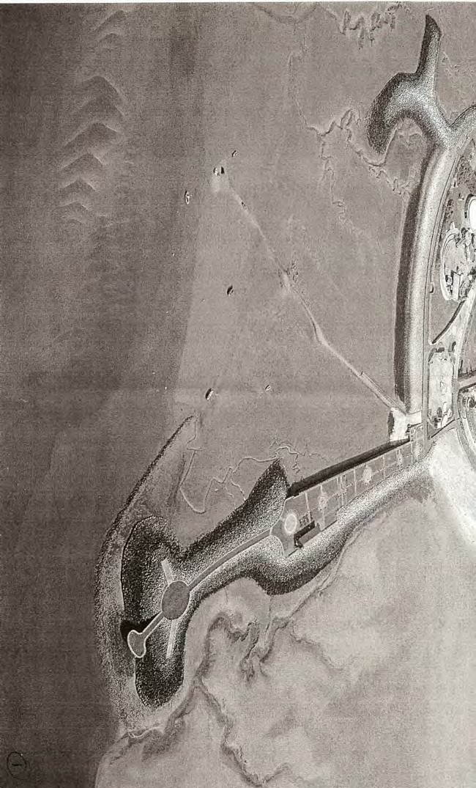

**Page 7**

**Zone 1** Stone Jetty Breakwater (Commercial **ONLY**)

**NB: If applying as a commercial fisherman:**

If this is a new application, Lancaster City Council require valid documentation stating that commercial fishing is your main occupation

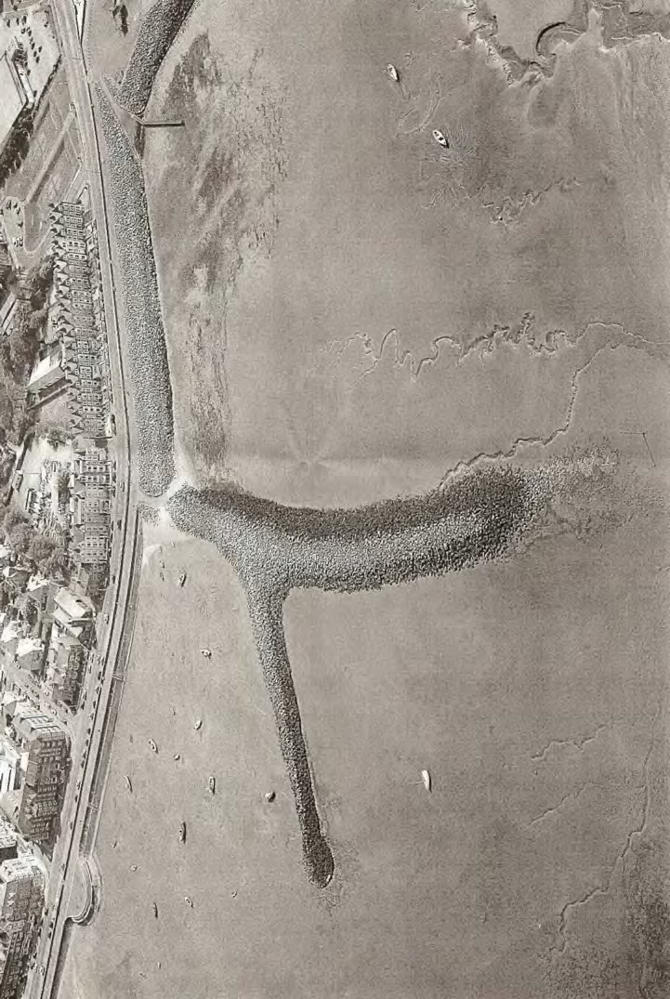

**Zone 2** Carlton Terrace Breakwater (Recreational **ONLY**)

**5. Declaration**

1. By completing this application, you agree with the following statements:

I am applying for an access permit and registering a mooring.

I have read and agree to abide with the conditions associated with this permit.

|  |  |  |  |  |  |  |  |  |  |
| --- | --- | --- | --- | --- | --- | --- | --- | --- | --- |
| D | D |  | M | M |  | Y | Y | Y | Y |

**Page 8**

Please send your completed application and all required documentation to:

**Promenade Permits, Town Hall, Marine Road East, Morecambe, LA4 5AF**

Any queries in relation to promenade permits should be sent to: **PublicRealm@lancaster.gov.uk**

(d) Print name

(b) Signed (c) Date

The permit is for the use of the stated vessel and will not be transferred.

I certify that to the best of my knowledge, the above particulars are true.

**Data Protection**

**Fraud:**

It is an offence for any person knowingly to give false information for the purpose of obtaining a Promenade Permit. Lancaster City Council will prosecute anyone who commits permit fraud.

Conviction will result in heavy penalties.

**Data Protection:**

The purpose of collecting all personal details listed in the previous form is for the City Council to process your application for a Promenade Permit. The City Council will store the details securely, confidentially within its ‘Community Engagement – Wellbeing’ team. Access to the information will be on a strictly need to know basis. This authority is under a duty to protect the public funds of its administers, and to this end may also use the information you have provided on this form for the prevention and detection of fraud.

**Data Protection Act 1998:**

The Data Protection Act 1998 is based on eight data protection principles that apply to the processing of all personal data including storing, retrieving, using and the disclosure of information.

To view Lancaster City Council’s Data Protection policy, please go to:

**www.lancaster.gov.uk**

**Equal Opportunities**

**Equal Opportunities:**

It is the policy of the City Council to provide equal opportunities in the fields of issuing promenade permits irrespective of the race, colour, nationality or ethnic national origins, religion, sex, sexuality, marital status, age, social background or the disability of applicants.

More information on Equal Opportunities can be found at **www.lancaster.gov.uk**

******Page 10**

**Page 9**

