

**B**

Lancaster City Council

**Promenade Permits**

# APPLICATION PACK (B)

Disabled Angler Permit - **Promenade Access**

**PACK INCLUDES:**

## General Information

## Code of Conduct

## Application Form

## Stone Jetty Parking Zone

## Data Protection Notes

**Please return the Application Form ONLY.**

**All other information is for your own records.**



Any queries in regard to this application pack should be emailed to:

**customerservices@lancaster.gov.uk**

**How to apply for your permit**

**When accessing Morecambe’s waterfront for a specific reason (i.e. launching**

**a fishing vessel) a permit is required. This is obtainable from Lancaster City**

**Council. You can apply for a permit in the following way:**



**BY POST**

Please return applications with the required documentation to:

**Promenade Permits, Town Hall, Marine Road East, Morecambe, LA4 5AF.**

http://www.eoa.co.uk/userfiles/images/email-symbol.jpg

**BY EMAIL\***

You can email your completed application to: **PublicRealm@lancaster.gov.uk**

**\*Please note applications sent via email will need to contain a signature or it will not be accepted**



**IN PERSON**

Completed applications can be dropped off at:

**Morecambe Town Hall, Monday – Friday, 09:00 – 17:00**

**Ways to pay...**

**Where there is a charge for the required permit, we can accept payment in the following ways:**

**BY CHEQUE**

Please make cheques payable to Lancaster City Council and enclose them with your application.

**BY CREDIT or DEBIT CARD**

Permits can also be paid for by credit or debit card by phoning **01524 582000**, and ask for Public Realm.

**P**

**a**

**ge**

**1**

**Annual Charges**

|  |  |  |
| --- | --- | --- |
| **Launching Permit** | Powered or non-powered craft | **£29.00** |
| **Disabled Angler Permit** | For use on Stone Jetty | **£29.00** |
|  | For use on Grosvenor Breakwater | **£15.00** |
| **Mooring Application** | All vessels | **NO CHARGE** |
| **Stone Jetty Commercial Access** | All commercial vessels | **NO CHARGE** |
| **Quad Bike Slipway Permit** | Commercial fishing **ONLY** | **£92.00** |
| **Quad Bike Bond** |  | **£336.00** |
| **Datatag** (One off charge) | Powered craft **ONLY** | **£75.00** |

**NB: Charges may change without prior notice.**

 **Code of Conduct**

**P**

**a**

**ge**

**2**

**Permit holders must agree and abide by the following when accessing Morecambe Promenade and its waterfront.**

**Coastal users should:**

•Be in possession of a valid permit, obtained from Lancaster City Council, allowing access to Morecambe’s promenade to launch a vessel/craft. The permit must be displayed in the **front** windscreen of the towing vehicle.

•Keep slipways clear of obstruction at all times. Please be aware that **no** parking is permitted on the foreshore.

•Indemnify Lancaster City Council, its employees and agents against any and all actions, costs, losses, damages, injury, charges, claims, expenses and damage whatsoever arising directly or indirectly from the use of the foreshore, except damage and injury arising from the negligence from the council and that of all its employees and agents.

•Observe all statutory provisions, regulations and orders as well as notices or documents received pursuant to any such requirement provision, regulation or order.

•Under no circumstances deposit litter or any other waste (including fish, shellfish or bait) on the foreshore or any adjoining land.

•Be aware that there are limited parking spaces available on the promenade, therefore if occupied, parking should be sought elsewhere. Areas to park at The Stone Jetty have been marked on the enclosed map.

•Always check weather reports, allow someone to know what time you expect to be back and check all safety equipment.

•Only access the promenade during the hours of daylight.

**NB: Permits can be revoked following non-adherence to any of the above conditions.**

**There is a speed limit of 10 mph and hazard lights must be in use while in motion on the promenade.**

**In the event of an emergency, dial** 999 **and ask for the coastguard**

**APPLICATION FORM B**

Disabled Angler Permit

(Stone Jetty & Grosvenor Breakwater)

**Page 3**





**B**

**Instructions:**

To access the promenade’s disabled parking spaces when angling, a permit is required. Access is granted via **The Stone Jetty** and **Grosvenor Breakwater**. If planning to access The Stone Jetty a swipe card is also required. Both are obtainable from the council on completing and returning this application form along with all required documentation to:

Promenade Permits, Town Hall, Marine Road East, Morecambe, LA4 5AF.

**NB:** A new permit will need to be purchased once the vehicle registration has changed or related documentation expires.

**This form is split into four colour-coded sections**

Permit Selection

General Information

Swipe Card Application

General Declaration

**a**

**b**

Please include the correct payment for the permit you require:

Stone Jetty Access Permit **£27.00**

Grosvenor Breakwater Access Permit **£15.00**

Lost or Stolen Cards Charge **£15.00**

**Payment**

To enable us to process your application, it is essential we have the following items:

* **2x Passport sized photographs of applicant** (45mm-35mm)
* **All parts (a), (b), & (d) completed**
* **Photocopy of your BLUE BADGE** (accurate and valid)
* **Full payment**

**Page 4**

**Items to be attached on submitting this form:**

General Information

Access Permit Application

Mooring Registration

Mooring Location

**This form is split into four colour-coded sections**

**Please Note:**

All applicants must complete parts **a**, **b** and **d**. If applying in regard to The Stone Jetty part **c** must also be completed.

**d**

**c**

**Important Notes**

**Important Notes**

**Stone Jetty Users:**

* Permit holders are required to park *in the centre of the jetty and not next to the railings*.
* There is a speed limit of 10mph and hazard lights must be in use while in motion on the promenade.
* A swipe card is needed to access parking at this location.
* There is £27.00 charge for this permit. Access via: **Barrier opposite Northumberland Street**.

**Grosvenor Breakwater Users**:

* There are limited parking bays at this location, and if full, alternative parking should be found.
* No swipe card is needed to access parking at this location.
* There is a £15.00 charge for this permit. Access via: **Oakley Road**

**Stone Jetty Users:**

* Permit holders should park in the centre of the jetty and not next to the railings.
* There is a speed limit of 10mph and hazard lights must be in use while in motion on the promenade.
* A swipe card is needed to access parking at this location.
* There is £20 charge for this permit. Access via: **Barrier opposite Northumberland Street**.

**Grosvenor Breakwater Users**:

* There are limited parking bays at this location, and if full, alternative parking should be found.
* No swipe card is needed to access parking at this location.
* There is a £8 charge for this permit. Access via: **Oakley Road**

This form can be used to **apply** for, or **renew** your disabled angler access permit, granting permission to access the promenade via **one** entry point, either The Stone Jetty or Grosvenor Breakwater. The permit is strictly **non-transferrable**.

Please use **BLOCK CAPITALS** when completing this form. **DATE OF APPLICATION:**

Use **BLACK INK** only

|  |  |  |  |  |  |  |  |  |  |
| --- | --- | --- | --- | --- | --- | --- | --- | --- | --- |
| D | D |  | M | M |  | Y | Y | Y | Y |

**Please (🗸) the most appropriate:** This is a new application This is a renewal

**Part A:** Permit Selection

**Please choose your permit type: (🗸)**

**Please choose your permit type: (🗸)**

1. Stone Jetty Access Permit ii) Grosvenor Breakwater Access Permit
2. Stone Jetty Access Permit ii) Grosvenor Breakwater Access Permit

**Part B:** General Information

**Part B:** General Information

1. **Applicant’s details**
2. Surname

(b) Forename

(c) Phone number

(d) Postal address

(e) Postcode

**Page 5**

**Page 5**

(c) Email Address

I am a disabled angler (🗸) Blue Badge REF Number

I am a disabled angler (🗸) Blue Badge REF Number

1. **Details of permitted blue badge**
2. Blue badge number

**Part C:** Swipe Card Application

Stone Jetty Applicants Only

1. **Ownership**
2. I already own a swipe card to gain entry (8 digit no)

(b) I do not own a swipe card and enclose the full payment to obtain one

**Part D:** General Declaration

I certify that to the best of my knowledge, the above particulars are true.

I certify that to the best of my knowledge, the above particulars are true.

I have read and agree to abide by the code of conduct.

The permit is for the use of the stated vessel and will not be transferred.

I am registered disabled.

1. By completing this application, you agree with the following statements:

**5. Declaration**

I have read and agree to abide with the conditions associated with this permit.

**Page 5**

|  |  |  |  |  |  |  |  |  |  |
| --- | --- | --- | --- | --- | --- | --- | --- | --- | --- |
| D | D |  | M | M |  | Y | Y | Y | Y |

Please send your completed application and all required documentation to:

**Promenade Permits, Town Hall, Marine Road East, Morecambe, LA4 5AF**

Any queries in relation to promenade permits should be sent to: **PublicRealm@lancaster.gov.uk**

**Page 6**

(d) Print name

(b) Signed (c) Date

|  |  |  |  |  |  |  |  |  |  |
| --- | --- | --- | --- | --- | --- | --- | --- | --- | --- |
| D | D |  | M | M |  | Y | Y | Y | Y |

(b) Signed (c) Date

**PLEASE RETAIN FOR YOUR OWN RECORDS**

**Stone Jetty Parking**

Once on the Stone Jetty, permit holders should park in the centre of the jetty and not adjacent to the railings. The map below shows the correct parking zone.

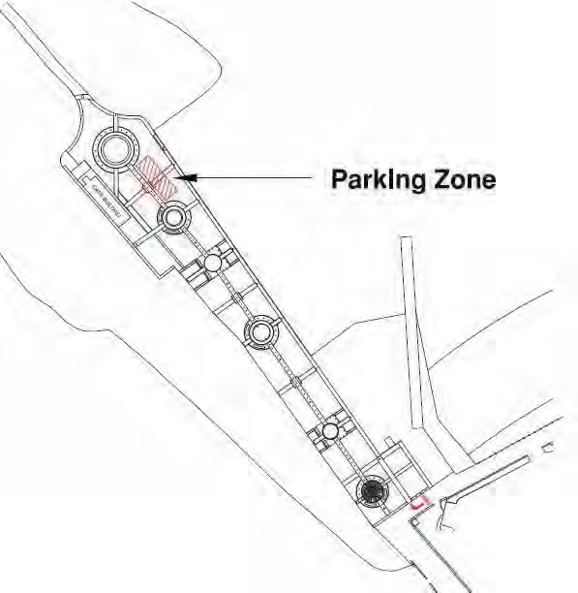



**Parking Zone**

**Page 7**

**Access Point 10mph**

**Data Protection**

**Fraud:**

It is an offence for any person knowingly to give false information for the purpose of obtaining a Promenade Permit. Lancaster City Council will prosecute anyone who commits permit fraud.

Conviction will result in heavy penalties.

**Data Protection:**

The purpose of collecting all personal details listed in the previous form is for the City Council to process your application for a Promenade Permit. The City Council will store the details securely, confidentially within its ‘Community Engagement – Wellbeing’ team. Access to the information will be on a strictly need to know basis. This authority is under a duty to protect the public funds of its administers, and to this end may also use the information you have provided on this form for the prevention and detection of fraud.

**Data Protection Act 1998:**

The Data Protection Act 1998 is based on eight data protection principles that apply to the processing of all personal data including storing, retrieving, using and the disclosure of information.

To view Lancaster City Council’s Data Protection policy, please go to:

**www.lancaster.gov.uk**

**Equal Opportunities**

**Equal Opportunities:**

It is the policy of the City Council to provide equal opportunities in the fields of issuing promenade permits irrespective of the race, colour, nationality or ethnic national origins, religion, sex, sexuality, marital status, age, social background or the disability of applicants.

More information on Equal Opportunities can be found at **www.lancaster.gov.uk**

******Page 10**



**Page 8**