DISHES AND THEIR ALLERGEN CONTENT
Note – Please state the name of the cereal(s) containing gluten* and the name of the nut(s)** in the appropriate column.

DISHES | 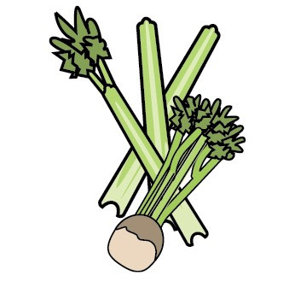 | 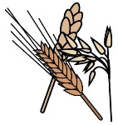 | 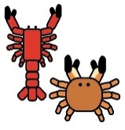 |  |  | 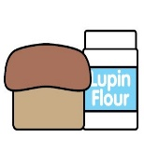 | 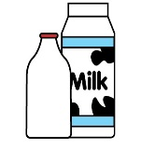 | 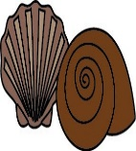 | 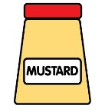 |  |  |  | 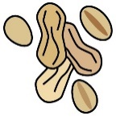 |  |  |  | Updated
 | Celery | *Cereals containing gluten | Crustaceans | Eggs | Fish | Lupin | Milk | Mollusc | Mustard | **Nuts |  |  | Peanuts | Sesame seeds | Soya | Sulphur  Dioxide/  Sulphites | Date/ Checked by
* Containing gluten (wheat, rye, barley & oats)
** Almonds, hazelnuts, walnuts, cashews, pecan, Brazil nuts, pistachio, macadamia: Means the dish contains the allergenic ingredient  MC – means the dish may contain the allergenic ingredient (if noted on ingredient label)  FC – means produced in a factory that also handles the allergen within the factory. |  |  |  |  |  |  |  |  |  |  |  | Date of issue:  Issued by:  Position:

