

Health and Housing Services

Adapting Your Home
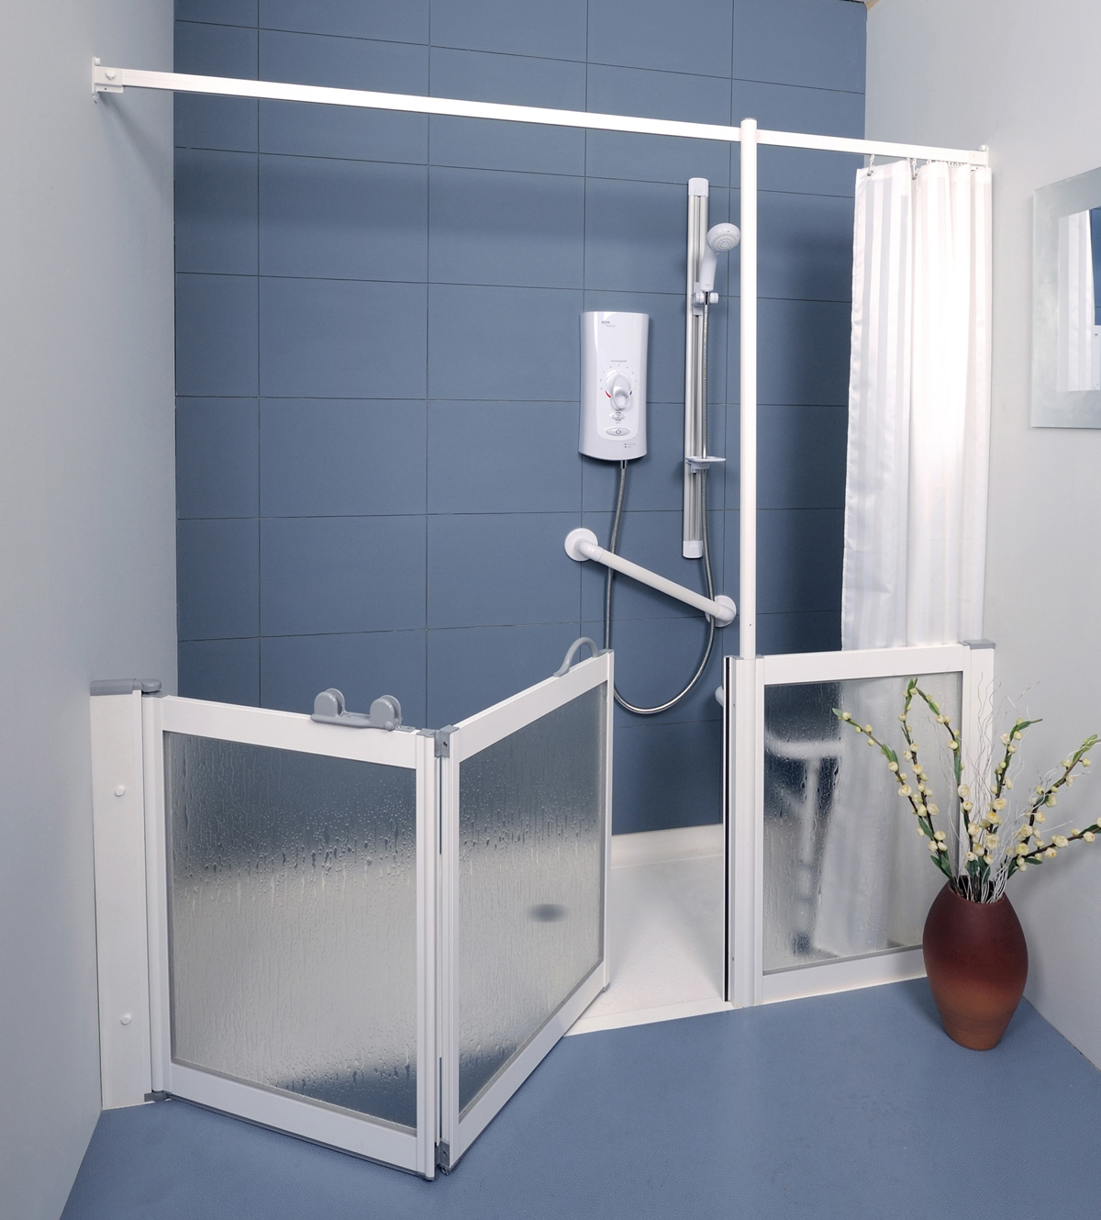
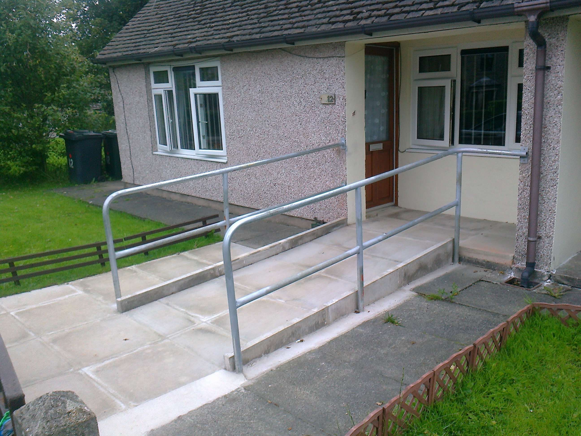

How we can help you or a member of your family to remain independent and active within your council home

About adapting your home

Are you or a member of your family finding it difficult to remain active and independent in your council home because of disability or ill health? It may be that life could be made easier by having adaptations made to your home.

Adaptations can be provided to assist you or a member of your family with a variety of daily living tasks. The sorts of adaptations that could be carried out include things like:
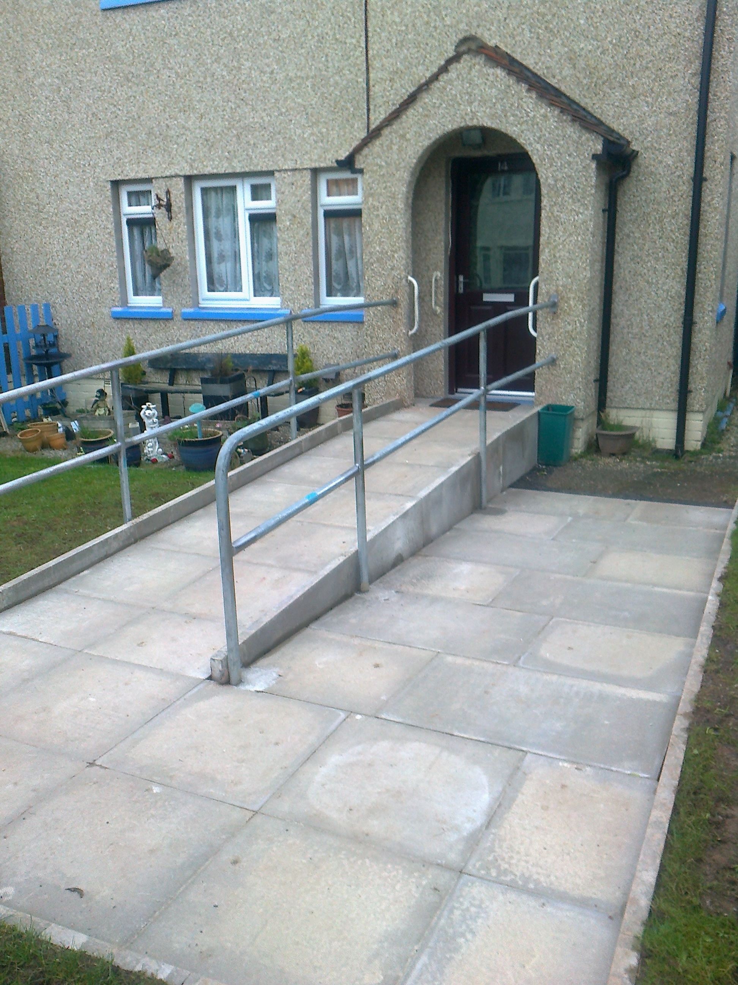
- Level access shower
- Grab rails
- Entrance ramp
- Stair lift
- Key safe
What do you need to do?

First of all you will need to be referred to an Occupational Therapist. To do this you need to contact Social Care at Lancashire County Council on 0300 1236720.

Occupational Therapists are part of the health service and are specially trained to work out what adaptations will be the most appropriate to you.

They will arrange to visit you in your home to assess what adaptations you need. They will discuss this assessment with you, and then send their recommendations to us at Health and Housing Services.

We will only carry out adaptation work once an Occupational Therapist has made an assessment, and any work we do will be based on their advice.

What happens once the recommendation has been sent to the council?
If the Occupational Therapist makes a recommendation for small scale, minor adaptations, they will ask us for permission to go ahead and carry out this work. As long as we agree to this, the adaptation work will then be carried out by Social Care Services at Lancashire County Council.

Depending on your circumstances, if the estimated cost of the adaptations required is more than £500 you may have to contribute towards this. We will send you a ‘Financial Assessment Form’ which we will use to work out how much your contribution to the cost of works might be.

If you have to contribute towards the cost of adaptation works, you will be asked to confirm whether or not you want to go ahead with them. If you are not able to pay your contribution in one go we can agree an arrangement with you to pay in instalments.

If you do not have to contribute, we will inform you of this and proceed with making arrangements to carry out the adaptations.

If planning permission or building regulation approval is needed we arrange for these applications to be made.

If extensive adaptations are required to your home which would be very costly or involve a large amount for work, for example the creation of an extra bedroom or bathroom, staff from Health and Housing Services will visit you along with the Occupational Therapist to discuss this, and to find the most appropriate solution.

What happens next?
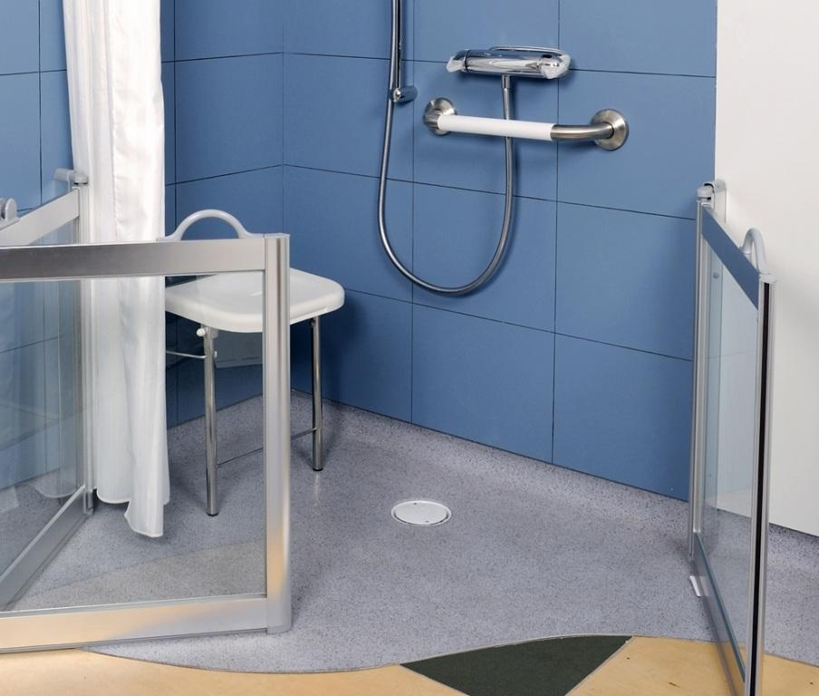

Depending on the nature of the adaptation work required there may be a wait before it can go ahead. When the contractor is ready to start the work they will contact you to let you know, and to arrange access. Where possible, at least 7 days notice will be given before the work begins.

It is always difficult to say for sure how long you might wait, as this depends on what adaptation work is currently being carried out for other people. If you are waiting for adaptation work you can contact using the details at the end of this leaflet, and we will try and give you an estimate as to when you can expect this to be carried out.

Once the adaptations have been completed we will let the Occupational Therapist know. The adaptations process is now complete.

Non-council tenants

If you need adaptations and you own your own home, or rent it from someone other than the Council, you can apply for a Disabled Facilities Grant. For more information contact Lancaster City Council’s Home Improvement Agency on 01524 582257, or at hiaenquiries@lancaster.gov.uk.

Contact Information

Lancaster City Council
Council Housing

Postal address:
PO Box 4, Town Hall, LANCASTER, LA1 1QR

Office:
38 Cable Street, LANCASTER, LA1 1HH

Telephone:
01524 582929

Email:
councilhousing@lancaster.gov.uk

Web site:
www.lancaster.gov.uk

Our office hours are 9.00 am to 5.00 pm weekdays
(10.00 am to 5.00 pm Wednesdays)

When the office is closed, if there is an emergency,
ring the Council’s Emergency Call Centre,
which is open 24 hours a day, 365 days a year.

The number to call is: 01524 67099

Calls may be recorded to help improve
our standard of service and accuracy of information



